In **Part 12** of this video series we have learnt the **basics of joins** and in **Part 13** we have learnt about **advanced or intelligent joins**. Please watch Parts 12 and 13 before watching this video  
[**Part 12 - Basic joins**](http://csharp-video-tutorials.blogspot.com/2012/08/joins-in-sql-server-part-12.html)  
[**Part 13 - Advanced joins**](http://csharp-video-tutorials.blogspot.com/2012/08/advanced-joins-part-13.html)  
  
   
  
   
  
   
  
In parts 12 and 13, we have seen joining 2 different tables - **tblEmployees**and **tblDepartments**. Have you ever thought of a need to join a table with itself. Consider tblEmployees table shown below.   
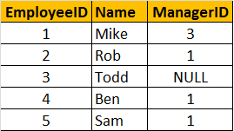   
  
Write a query which gives the following result.   
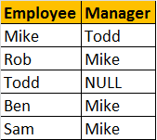  
  
  
**Self Join Query:**   
A MANAGER is also an EMPLOYEE. Both the, EMPLOYEE and MANAGER rows, are present in the same table. Here we are joining tblEmployee with itself using different alias names, E for Employee and M for Manager. We are using LEFT JOIN, to get the rows with ManagerId NULL. You can see in the output TODD's record is also retrieved, but the MANAGER is NULL. If you replace LEFT JOIN with INNER JOIN, you will not get TODD's record.  
Select E.Name as Employee, M.Name as Manager  
from tblEmployee E  
Left Join tblEmployee M  
On E.ManagerId = M.EmployeeId  
  
  
In short, joining a table with itself is called as **SELF JOIN**. SELF JOIN is not a different type of JOIN. It can be classified under any type of JOIN - INNER, OUTER or CROSS Joins. The above query is, LEFT OUTER SELF Join.  
  
**Inner Self Join tblEmployee table:**  
Select E.Name as Employee, M.Name as Manager  
from tblEmployee E  
Inner Join tblEmployee M  
On E.ManagerId = M.EmployeeId  
  
**Cross Self Join tblEmployee table:**  
Select E.Name as Employee, M.Name as Manager  
from tblEmployee  
Cross Join tblEmployee